**FINAL REPORT TEMPLATE: DATE: 20/05/2020**

**NUMISTAR: A COLLECTOR’S DESK**

INTRODUCTION:

This year I am planning to upload my currency collection on internet for a world record inspection. I want to put my collection on bid sale after that.

This will benefit me to collect some money from my collection, which I can further use for Masters studies. Also, the end user ,that is , both the Guinness and the buyer would benefit as he would get to the collection with the actual image. There will be an introduction/about page in my project from where people can know more about my project.

I am going to include images from my collection as well as resources. It means that it will contain both local image uploading as well the use of anchor tags. Further, I will be using the anchor tags to link the website like numista to help my user get more information about the collection.

**DESIGN AND IMPLEMENTATION:**

* **I FIRST VISITED VARIOUS WEBSITES RELATED TO NUMISMATICS AND COIN FORUMS.**
* **IT HELPED ME TO FORM AN IMAGE OF WEBSITE PREHAND.**
* **I MADE A VARIOUS NUMBER OF CHOICES ALONG WITH THE HELP OF THE RISTORANTE CONFUSION WESITE THAT JOGESH MUPPALA SIR TAUGHT US.**
* **THE CHOICES WERE TO ADD A COLLECTION PAGE TO MY PROJECT ALONG WITH ADDITION OF A BOOTSTRAP CLASS CALLED SCROLLBAR**
* **SCROLLBAR USES BOTH JAVASCRIPT AS WELL AS CSS FEATURES.**
* **LIBRARIES SUCH AS NPM, NODE, BOOTSTRAP, ETC. WERE USED IN MY PROJECT.**
* **I MADE USE OF FORMS, CAROUSEL, MODALS, ETC. WHICH USES JAVASCRIPT CLASSES ALONG WITH A JQUERY CODE.**
* **MY SITE CONSISTS OF A HEADER AND FOOTER IN WHICH NAVBAR IS FIXED TO THE TOP AND FOOTER IS STATIC BOTTOM. THE FOOTER IS SAME ACROSS ALL THE PAGES.**
* **THE HEADER CHANGES WITH DIIFERENT PAGES.**
* **THE PROJECT CONSISTS OF A TABLE WHICH HAVE USED TABLE-DARK CLASS AND SHOWCASES MY COLLECTION.**

**A FEW SCREENSHOTS OF MY WEBSITE :-**

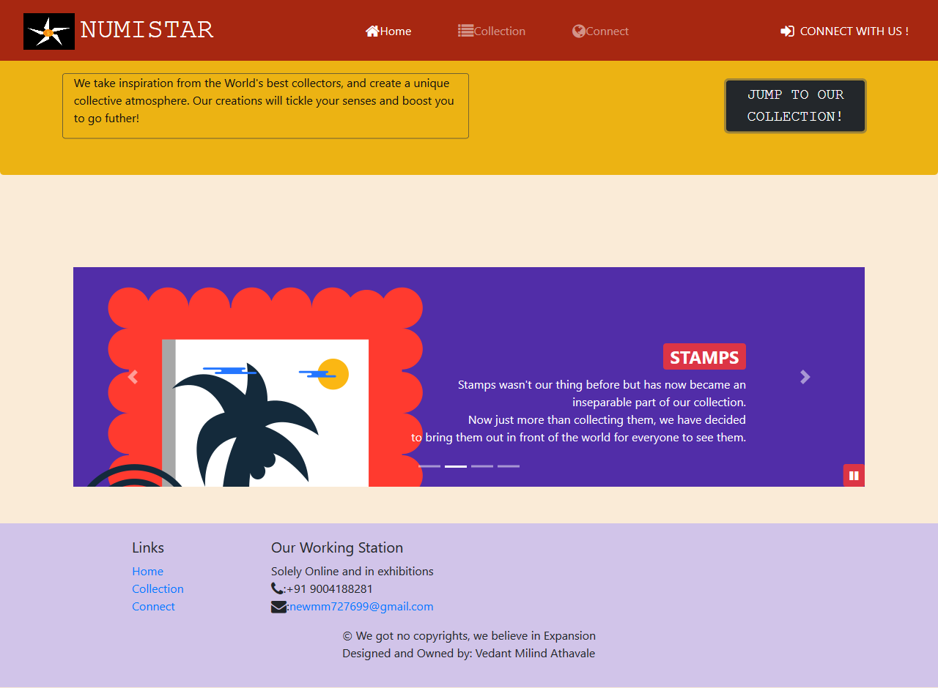

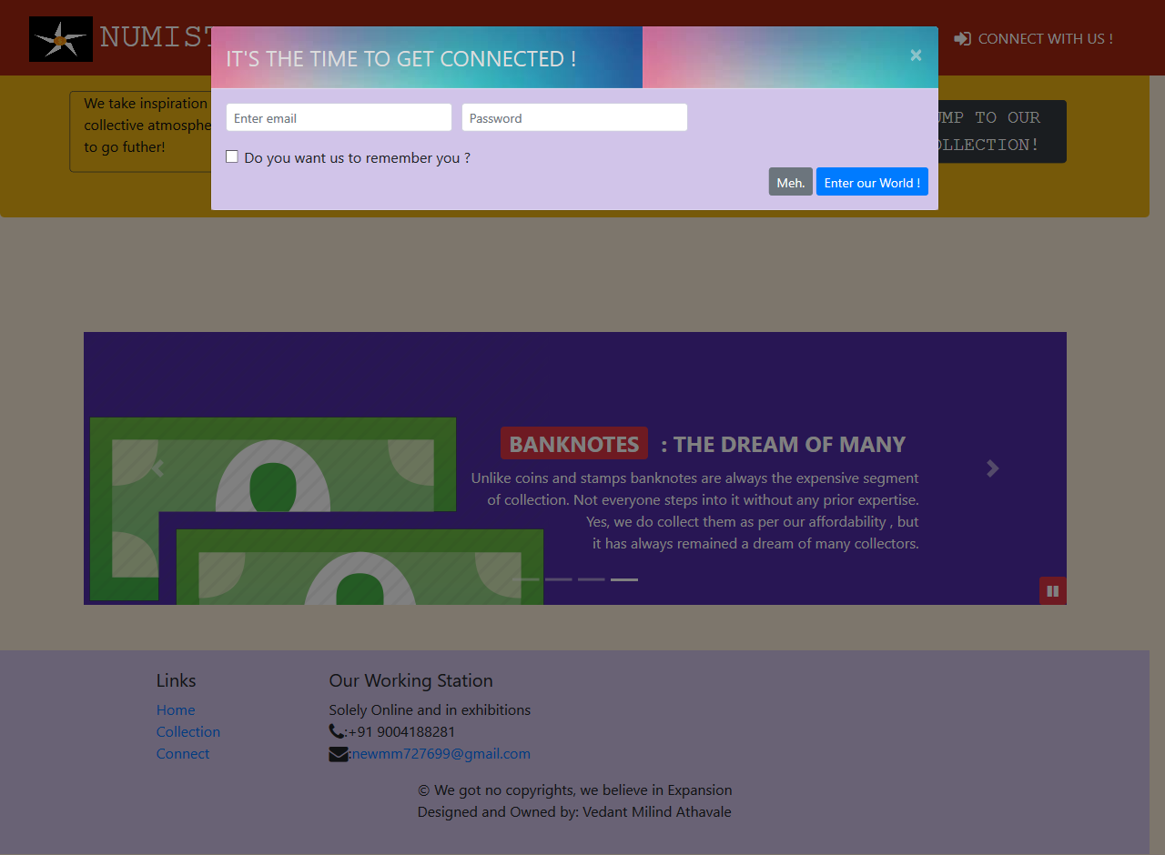

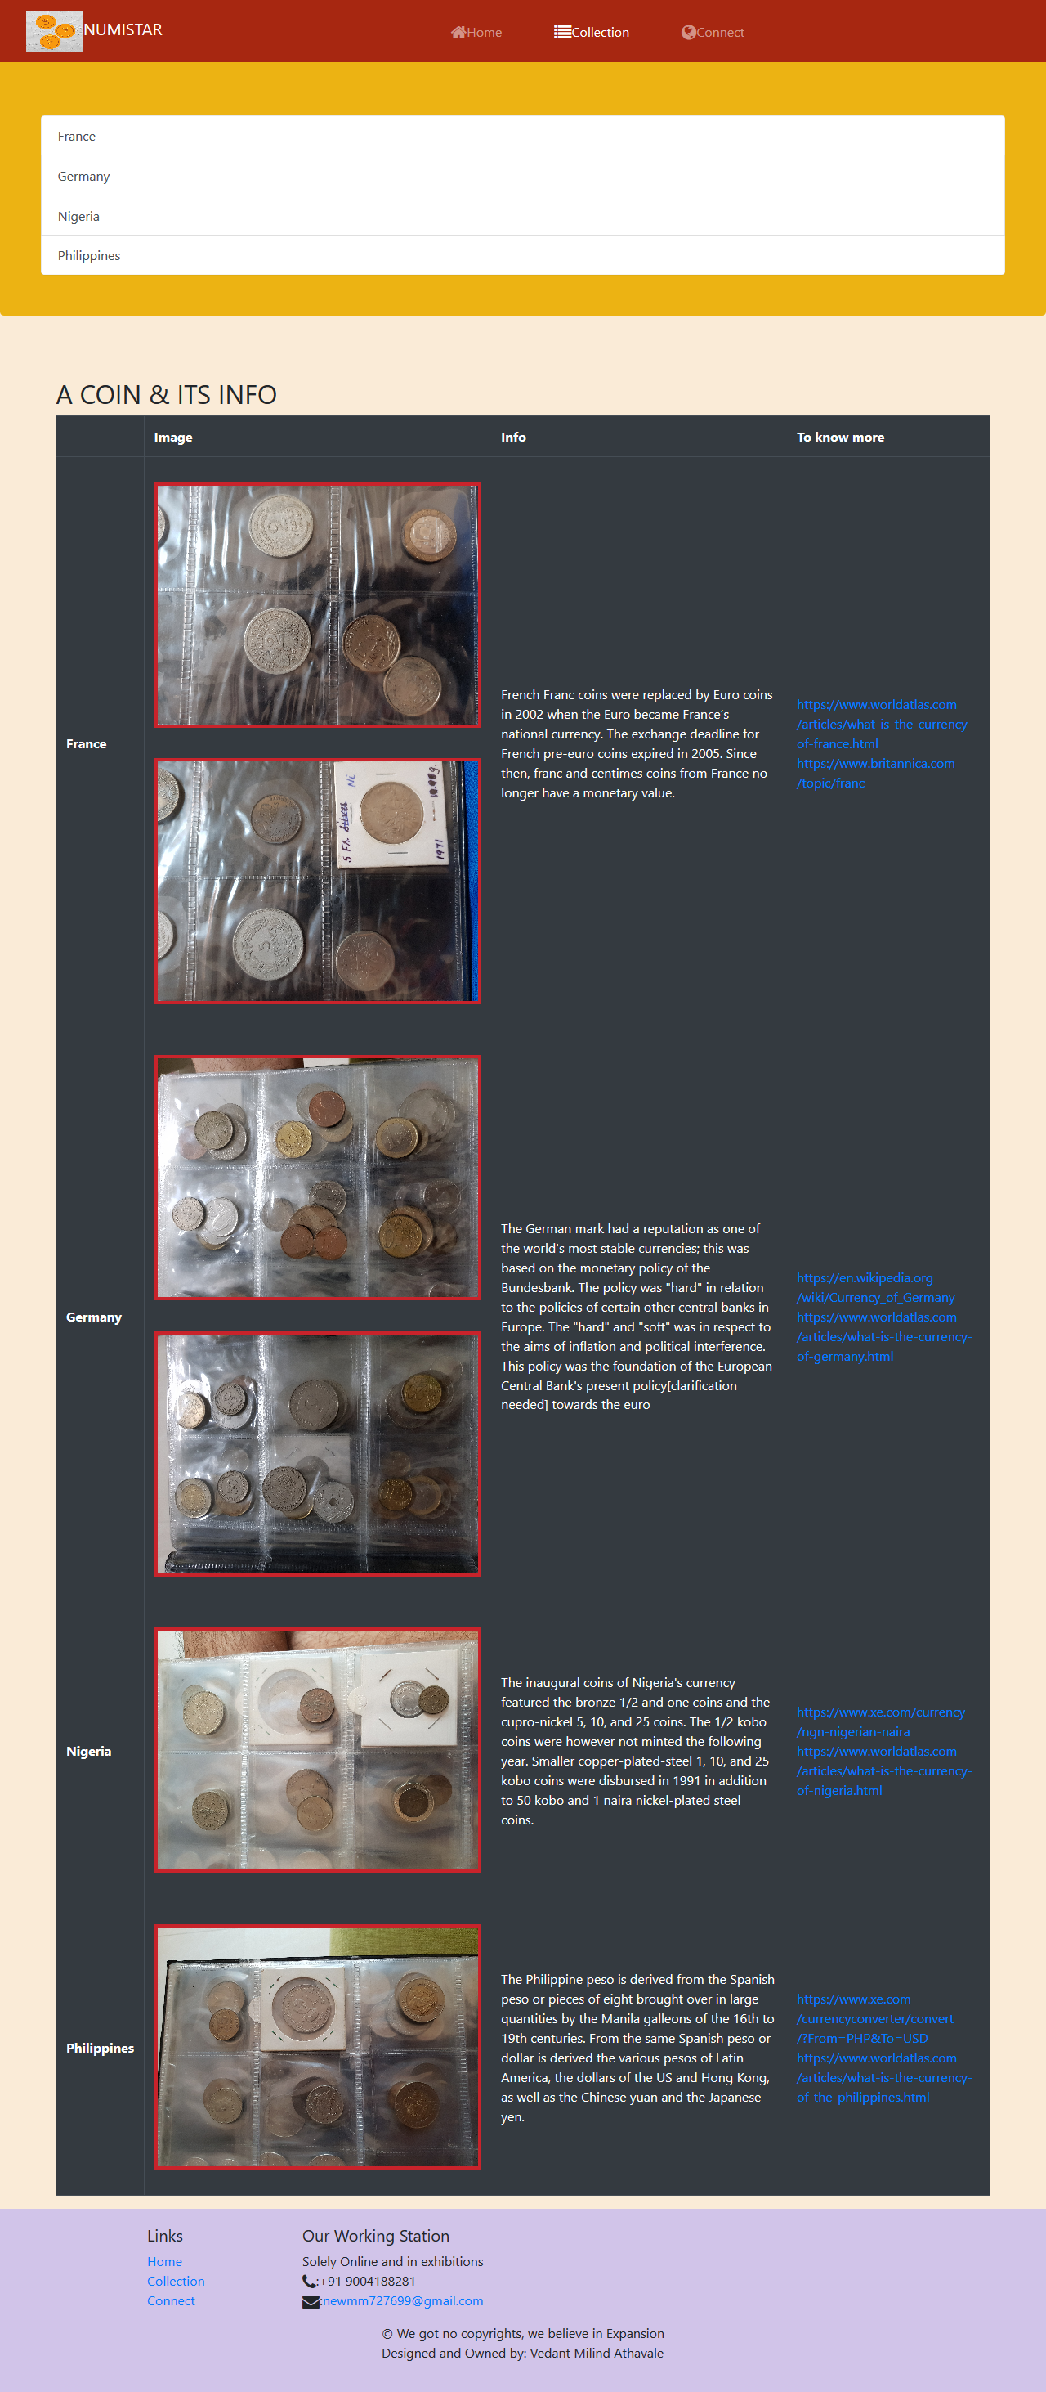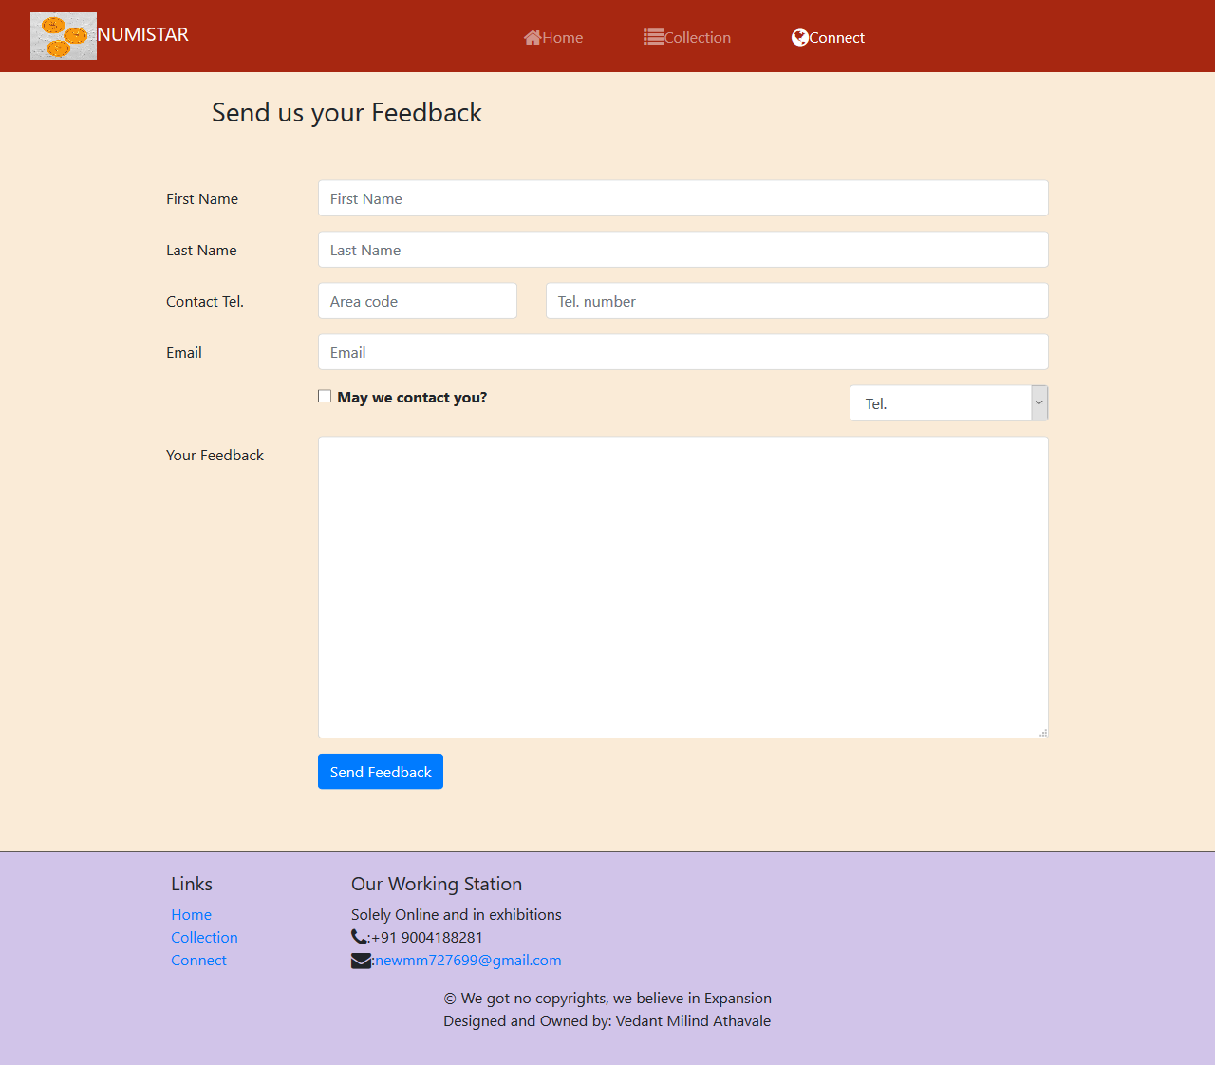

**CONCLUSIONS**

* **THIS PROJECT WAS NOT ONLY MADE BY ME TO GAIN AN HONORS CERTIFICATE. I HAD BEEN THINKING OF LONG TO CREATE MY OWN WEBSITE WHERE I CAN SHOWCASE MY HOBBY IN FRONT OF THE WORLD.**
* **AFTER THE COMPLETION OF MAKING THIS WEBSITE (AS I HAVE ONLY LEARNT FRONT-END AND YET TO ENTER THE BACK END), THE SERVER SIDE DEVELOPMENT ALONG WITH THE USE OF MONGO DB WILL BE DONE IN FUTURE.**
* **I ASPIRE TO BE A FULL STACK DEVELOPER AND WORK LARGELY IN THE SEO FIELD WHICH WILL HELP TO GET INTO A GOOD INTERNSHIP AS IT WILL HELP ME PURSUE MY MASTERS WITH SOME PRIOR EXPERIENCE.**
* **FROM THIS PROJECT, I LEARNT HTML, CSS AND JS ALONG WITH A LARGE NUMBER OF BOOTSTRAP UTILITIES AND COMPONENTS. MY NEXT TARGET IS TO LEARN REACT.JS.**

REFERENCES:-

1. <https://www.feedspot.com/infiniterss.php?_src=feed_title&followfeedid=1425126&q=site:https%3A%2F%2Fcoinweek.com%2Ffeed%2F>
2. <https://www.feedspot.com/infiniterss.php?_src=feed_title&followfeedid=1425136&q=site:https%3A%2F%2Fwww.numismaticnews.net%2Ffeed>
3. <https://www.feedspot.com/infiniterss.php?_src=feed_title&followfeedid=4641647&q=site:http%3A%2F%2Fnews.coinupdate.com%2Ffeed%2F>
4. <https://www.feedspot.com/infiniterss.php?_src=feed_title&followfeedid=4643354&q=site:http%3A%2F%2Fblog.perthmint.com.au%2Ffeed%2F>
5. <https://www.feedspot.com/infiniterss.php?_src=feed_title&followfeedid=4643327&q=site:http%3A%2F%2Fnumismatics.org%2Fpocketchange%2Ffeed%2F>

**THANK YOU !**